Log in to Jira and go to Projects > Create Project.

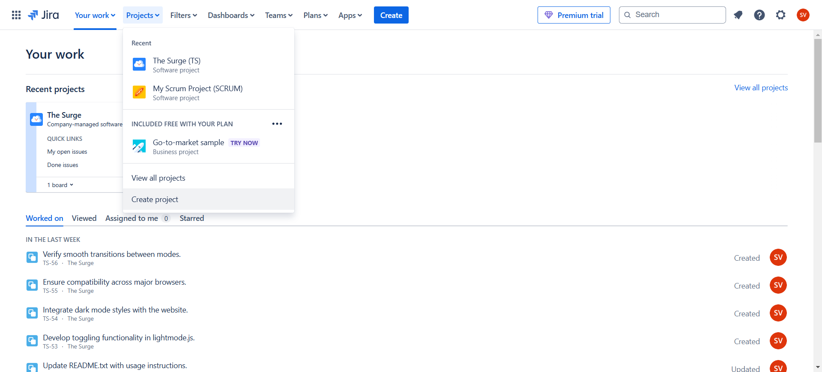

Select Kanban as the project type and click on use template on the next page

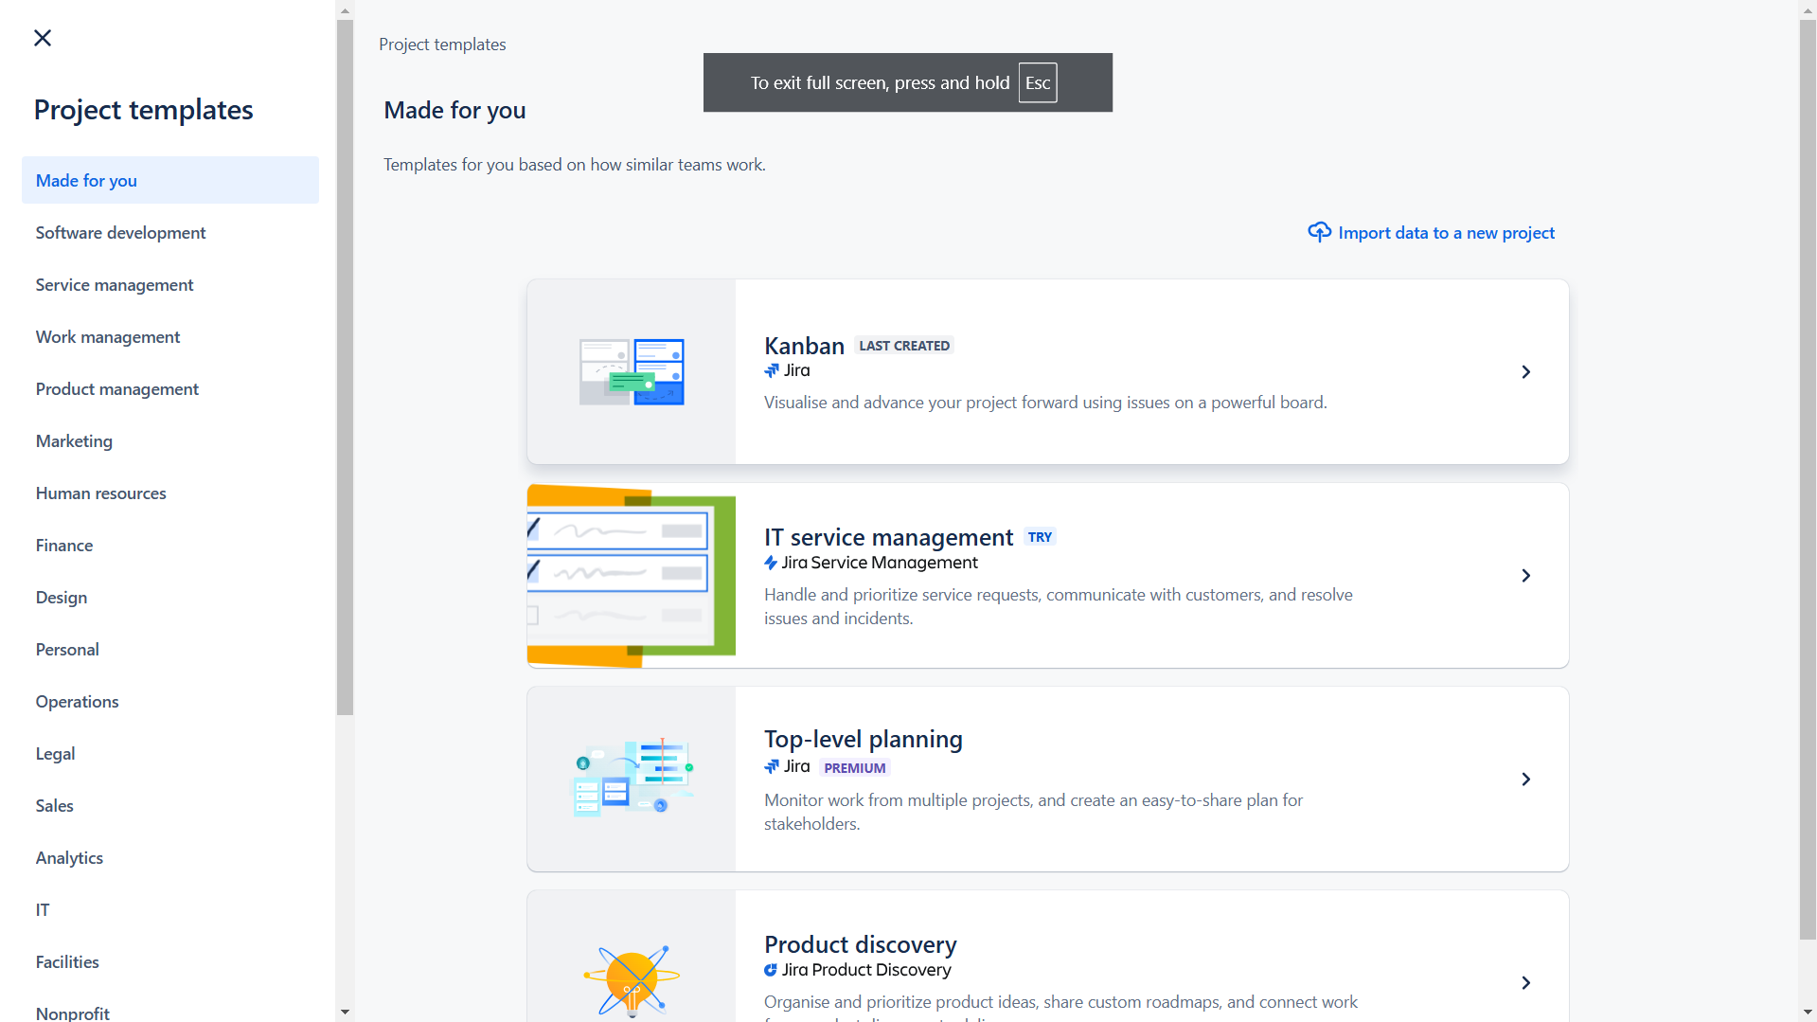

Select company -managed project as project type

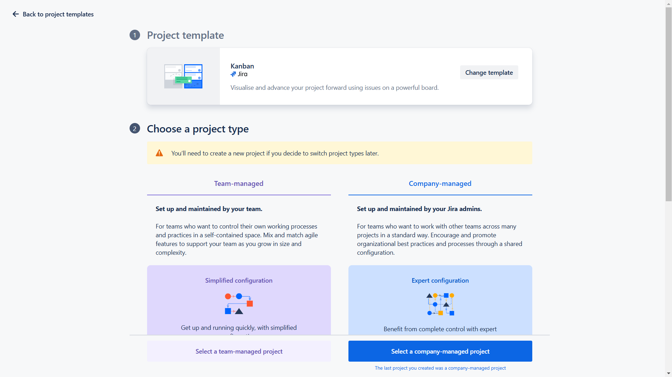

Name the project and choose any project key of your choice

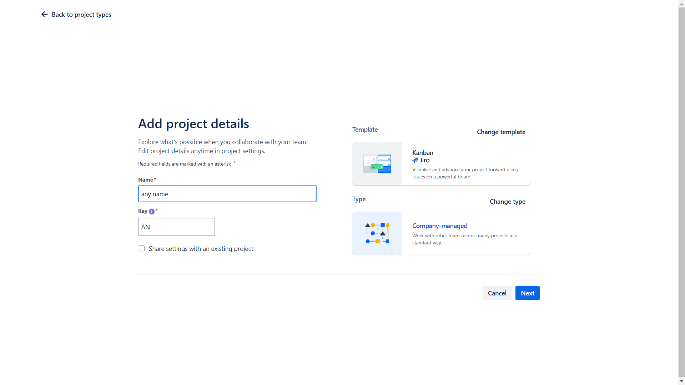

After creating, click on create issue under the backlog column. Make the issue an epic

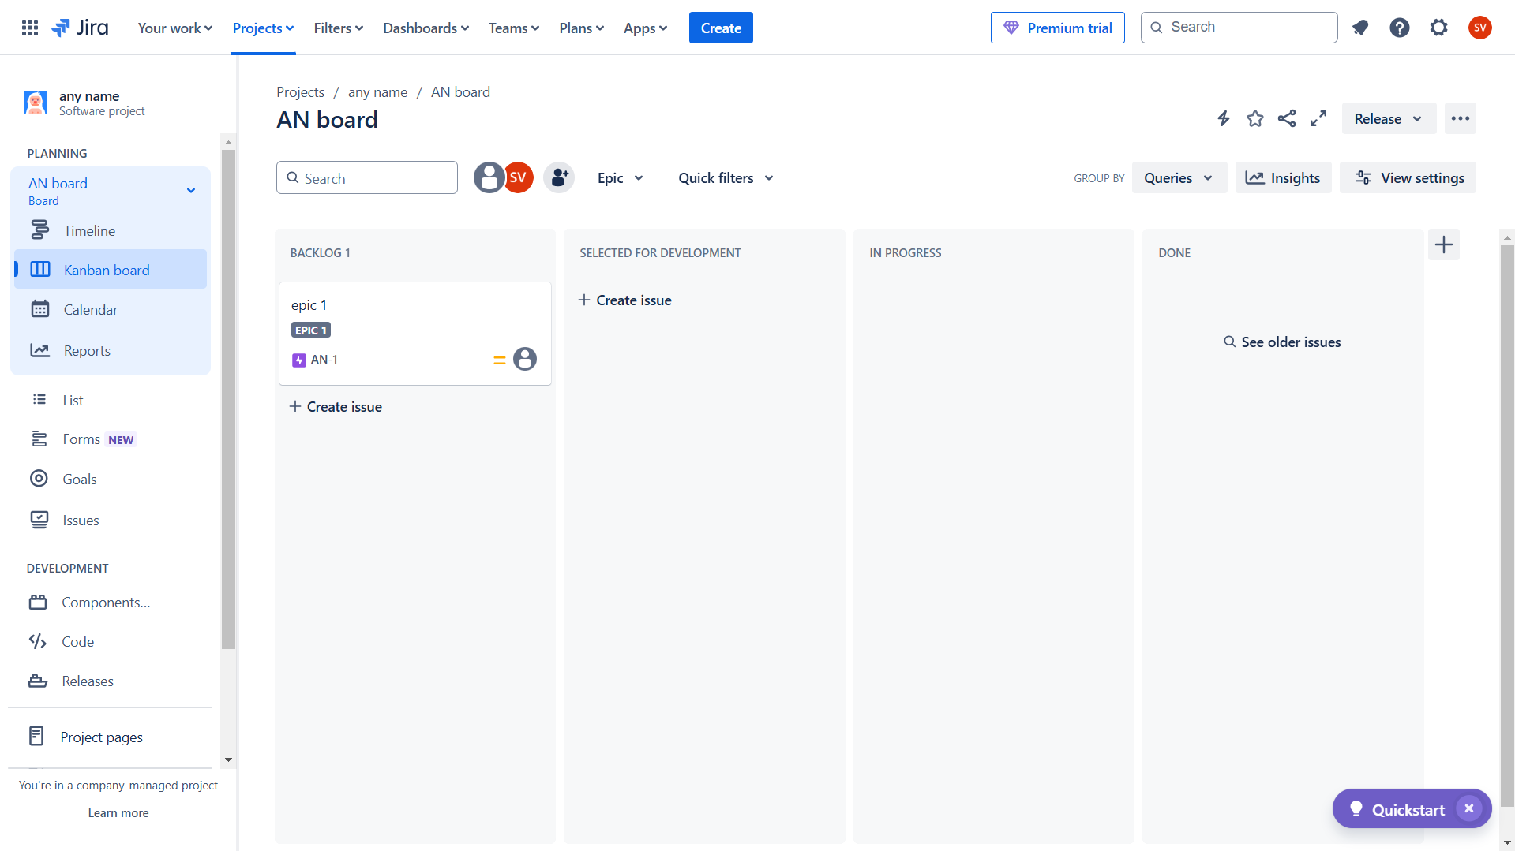

Click on the epic and choose child issue to create stories under the epic that acts as a sub work for the epic

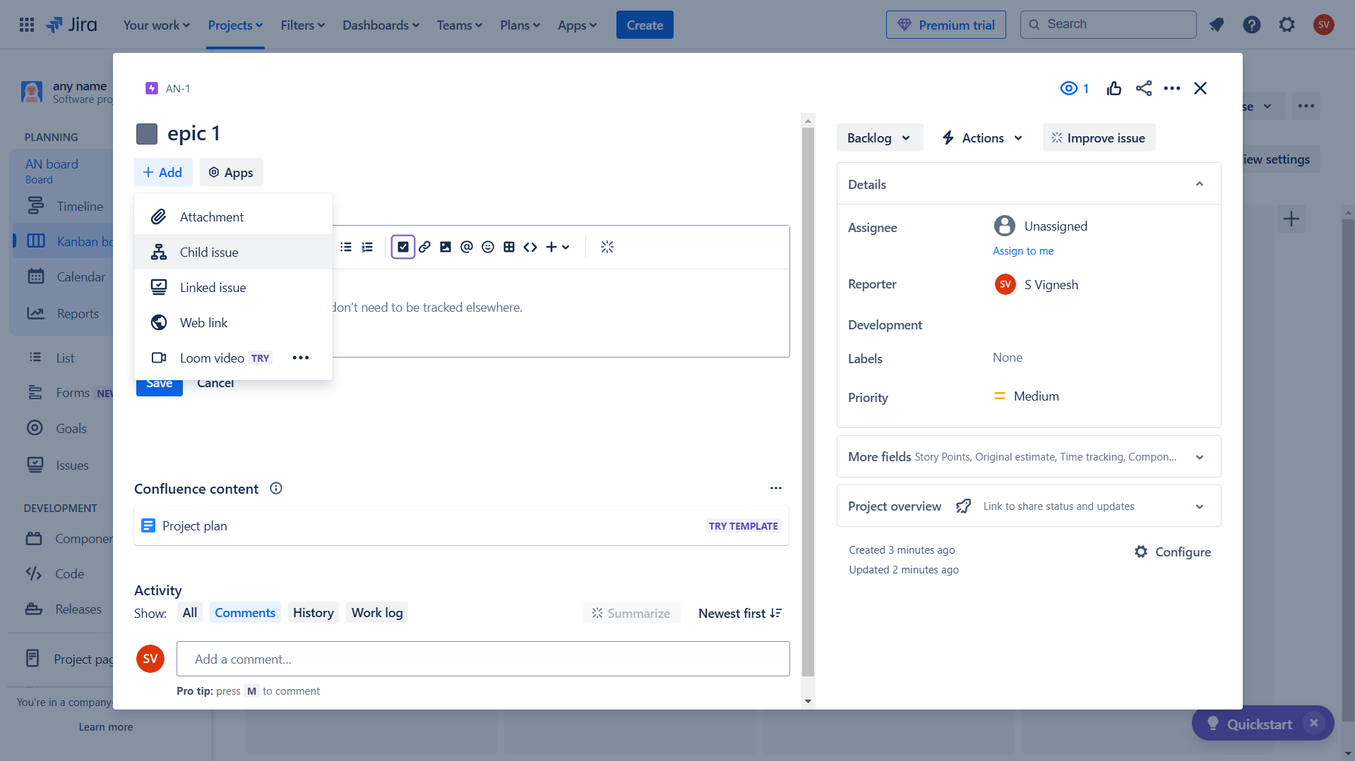

Change the issue as story and name it.

Similarly create sub tasks under stories which acts as a basic task to complete for the development

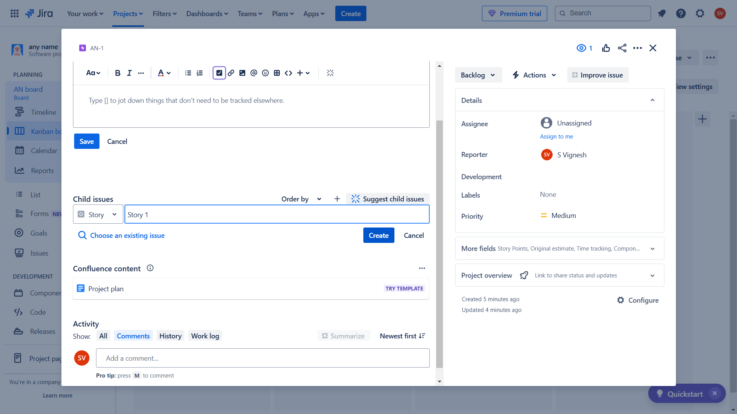

After creating the required epics, stories and sub tasks drag and drop the required epics in to columns that it falls under based on the progression of your project

